TASK 4 – EVENT-HANDLING FORENSICS Bloom’s Level: K4 – Analyse
7 Marks
A drawing pad is supposed to draw a dot wherever the user clicks and showthe clickcount in a label. Users report that nothing is drawn and the count stays at 0.
public class DrawPad extends Frame {
int count = 0; Label status = new Label("Clicks: 0"); public DrawPad() {
add(status, BorderLayout.SOUTH);
addMouseListener(new MouseAdapter() {
public void mouseclicked(MouseEvent e) {
count++;
Graphics g = getGraphics(); g.fillOval(e.getX(), e.getY(), 6, 6); }
});
setSize(400, 300); setVisible(true);
}
}

Task 4.1 – Locate the Defect | 2 Marks
Identify why the click is never handled and why the label never changes. Task 4.2 – Construct a Failing Interaction | 2 Marks
Even after the first defect is fixed, the dots disappear when the window is minimised andrestored. Describe the interaction that reveals this and explain why it happens.
Task 4.3 – Repair the Program | 2 Marks
Correct the program so that clicks are counted, the label updates and the dots surviverepainting (store the points and draw them in paint()).
Task 4.4 – Prevent Recurrence | 1 Mark
Explain how the @Override annotation would have exposed the first defect at compiletime.
Complete the Code
Complete TODO 1 and TODO 2 below, execute the program and attach screenshotsbefore and after minimising the window.
import java.awt.BorderLayout;
import java.awt.Frame;
import java.awt.Graphics;
import java.awt.Label;
import java.awt.Point;
import java.awt.event.MouseAdapter;
import java.awt.event.MouseEvent;
import java.awt.event.WindowAdapter;
import java.awt.event.WindowEvent;
import java.util.ArrayList;
import java.util.List;
public class DrawPad extends Frame {
private final List<Point> points = new ArrayList<>(); private final Label status = new Label("Clicks: 0");
public DrawPad() {
super("Draw Pad");
add(status, BorderLayout.SOUTH);
addMouseListener(new MouseAdapter() {
// TODO 1: Override mouseClicked correctly: store the point, update the// label and request a repaint
});
addWindowListener(new WindowAdapter() {
@Override public void windowClosing(WindowEvent e) { dispose(); }});
setSize(400, 300);
}
@Override public void paint(Graphics g) {
// TODO 2: Draw every stored point as a 6 × 6 filled circle centred on the point}
public static void main(String[] args) { new DrawPad().setVisible(true); }}

Remove @Override from TODO 1, misspell the method as mouseclicked, and recordthecompiler message.
Alternative Concept and Complexity Analysis
Your repaired design stores the points and redraws them in paint(). If the dots wereinstead drawn once onto an off-screen BufferedImage that is copied to the screeninpaint(), what would the solution be? Analyse the time per repaint for n clicks (O(n) versuscopying one image) and the space used (O(n) points versus width × height pixels).
Evidence Expected
Correct defect identification, a reproducible failing interaction, a repaired programandaprevention measure.

Defect | Explanation
Incorrect method name | mouseclicked() is incorrect. Java requires mouseClicked() with a capital C.
Incorrect label handling | The code increases count but never updates the status label.
Using getGraphics() | Drawing directly with getGraphics() is temporary. The dots may disappear when the window is repainted.
Correct method name:
@Override
public void mouseClicked(MouseEvent e)

Q4.2 – Construct a Failing Interaction (2 Marks)
- Open the drawing pad.
- Click several times in the drawing area.
- Observe that the dots may appear temporarily.
- Minimise the window.
- Restore the window.
What happens?
The dots disappear after restoring the window because the program draws directly using getGraphics(). These drawings are not stored permanently, so they cannot be redrawn when the window is repainted.
The failure can be reproduced by clicking several times, minimising the drawing pad and then restoring it. The dots disappear because they were drawn directly on the screen using getGraphics() instead of being stored. When the window is repainted, the temporary drawings are lost.

Q4.3 – Repair the Program (2 Marks)


import java.awt.BorderLayout;
import java.awt.Frame;
import java.awt.Graphics;
import java.awt.Label;
import java.awt.Point;
import java.awt.event.MouseAdapter;
import java.awt.event.MouseEvent;
import java.awt.event.WindowAdapter;
import java.awt.event.WindowEvent;
import java.util.ArrayList;
import java.util.List;

public class DrawPad extends Frame {

private final List<Point> points = new ArrayList<>();
private final Label status = new Label("Clicks: 0");

public DrawPad() {
super("Draw Pad");

add(status, BorderLayout.SOUTH);

addMouseListener(new MouseAdapter() {

// TODO 1: Handle mouse clicks
@Override
public void mouseClicked(MouseEvent e) {
points.add(e.getPoint());

status.setText("Clicks: " + points.size());

repaint();
}
});

addWindowListener(new WindowAdapter() {
@Override
public void windowClosing(WindowEvent e) {
dispose();
}
});

setSize(400, 300);
}

@Override
public void paint(Graphics g) {

super.paint(g);

// TODO 2: Draw all stored points
for (Point p : points) {
g.fillOval(p.x - 3, p.y - 3, 6, 6);
}
}

public static void main(String[] args) {
new DrawPad().setVisible(true);
}
}

Understanding the two TODO sections
TODO 1:
points.add(e.getPoint());
status.setText("Clicks: " + points.size());
repaint();
- 
points.add() stores the clicked location.
- status.setText() updates the click counter.
- repaint() requests that the window be redrawn.
TODO 2:
for (Point p : points) {
g.fillOval(p.x - 3, p.y - 3, 6, 6);
}

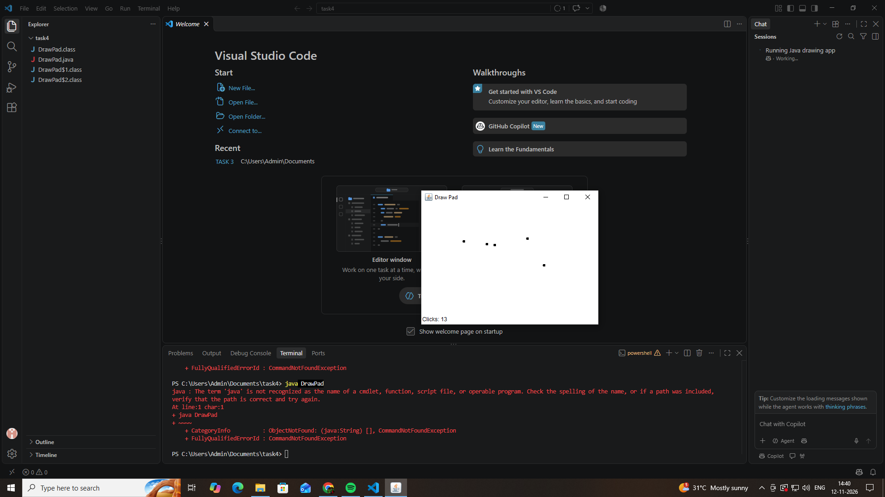

4.4 – Prevent Recurrence (1 Mark)
Write this explanation in your assignment:
The @Override annotation helps identify incorrect method names and signatures at compile time. If mouseClicked() is misspelled as mouseclicked(), the compiler reports an error because the method does not correctly override the superclass method. This prevents the programmer from unknowingly writing a listener method that is never called.

